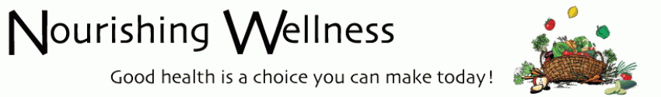

Dump the Junk Detox
Conference Call

Wednesday April 9th
6:30 pm

Dial-in-number
605-562-3000
Access Code: 465949#

Agenda:
- Details of the upcoming week- the home stretch of DUMP the Junk Detox

- Live Q&A and discussion. If you’d like email your questions ahead of time to Linda@NourishingWellness.net

